# K-Nearest Neighbors

**Instructions:**

Please share your answers filled in-line in the word document. Submit code separately wherever applicable.

Please ensure you update all the details:

**Name: Biswajeet Padhi Batch ID:** 280921

**Topic: K-Nearest Neighbors**

**Grading Guidelines:**

**1. An assignment submission is considered complete only when correct and executable code(s) are submitted along with the documentation explaining the method and results. Failing to submit either of those will be considered an invalid submission and will not be considered for evaluation.**

**2. Assignments submitted after the deadline will affect your grades.**

**Grading:**

|  |  |  |  |  |  |
| --- | --- | --- | --- | --- | --- |
| **Ans** | **Date** |  |  | **Ans** | **Date** |
| Correct | On time | A | 100 |  |  |
| 80% & above | On time | B | 85 | Correct | Late |
| 50% & above | On time | C | 75 | 80% & above | Late |
| 50% & below | On time | D | 65 | 50% & above | Late |
|  |  | E | 55 | 50% & below |  |
| Copied/No Submission |  | F | 45 |  |  |

* **Grade A: (>= 90):** When all assignments are submitted on or before the given deadline.
* **Grade B: (>= 80 and < 90):** 
  + When assignments are submitted on time but less than 80% of problems are completed.

(OR)

* + All assignments are submitted after the deadline.
* **Grade C: (>= 70 and < 80):** 
  + When assignments are submitted on time but less than 50% of the problems are completed.

(OR)

* + Less than 80% of problems in the assignments are submitted after the deadline.
* **Grade D: (>= 60 and < 70):**
  + Assignments submitted after the deadline and with 50% or less problems.
* **Grade E: (>= 50 and < 60):** 
  + Less than 30% of problems in the assignments are submitted after the deadline.

(OR)

* + Less than 30% of problems in the assignments are submitted before the deadline.
* **Grade F: (< 50):** No submission (or) malpractice.

**Hints:**

1. **Business Problem**
   1. **What is the business objective?**
   2. **Are there any constraints?**
2. **Work on each feature of the dataset to create a data dictionary as displayed in the below image:**

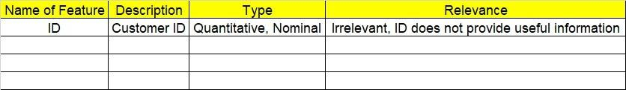

**2.1 Make a table as shown above and provide information about the features such as its data type and its relevance to the model building. And if not relevant, provide reasons and a description of the feature.**

1. **Data Pre-processing**

**3.1 Data Cleaning, Feature Engineering, etc.**

1. **Exploratory Data Analysis (EDA):**
   1. **Summary.**
   2. **Univariate analysis.**
   3. **Bivariate analysis.**
2. **Model Building**
   1. **Build the model on the scaled data (try multiple options).**
   2. **Perform KNN and use cross validation techniques to get optimum K value.**
   3. **Train and test the model and perform cross validation techniques. Compare accuracies, precision and recall and explain them in the documentation.**
   4. **Briefly explain the model output in the documentation.**

1. **Write about the benefits/impact of the solution - in what way does the business (client) benefit from the solution provided?**
2. A glass manufacturing plant uses different earth elements to design new glass materials based on customer requirements. For that, they would like to automate the process of classification as it’s a tedious job to manually classify them. Help the company achieve its objective by correctly classifying the glass type based on the other features using KNN algorithm.

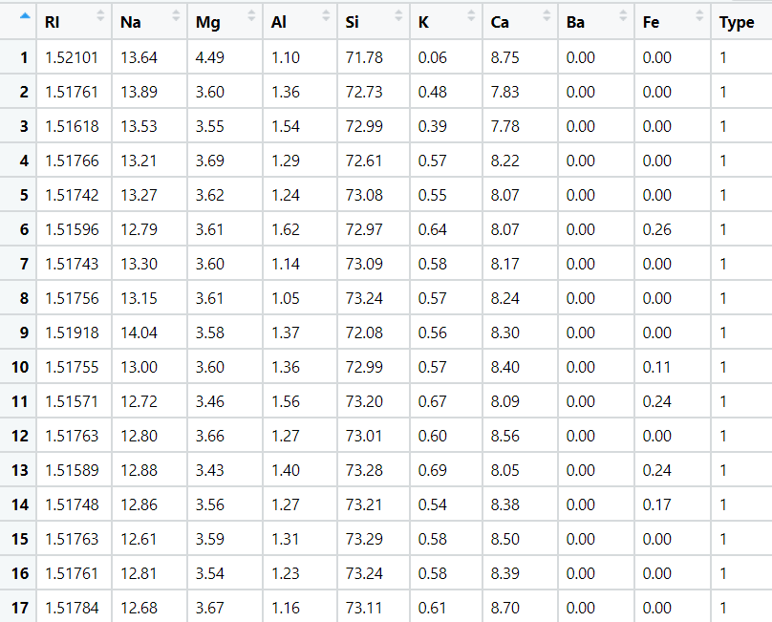



1. 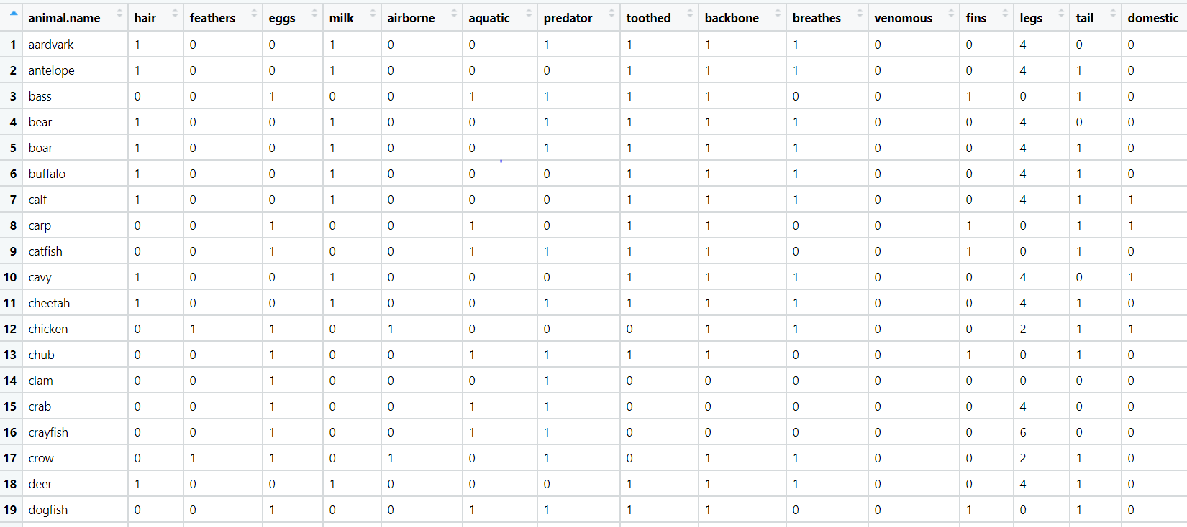A National Park in India is dealing with the problem of segregation of its species based on the different attributes they have. Build a KNN model to automatically classify new species. Explain any inferences you draw in the documentation.